**PRACTICAL – 7(1-A)**

**Aim: Write a program to create thread which display “Hello World” message.**

**A. by extending Thread class**

**B. by using Runnable interface.**

**SOURCE CODE-A:**

public class Practical_7_1_A extends Thread {

    public *void* run() {

        System.out.println("Hello World");

        System.out.println("\n20DCE019-Yatharth Chauhan");

    }

    public static *void* main(String[] *args*) {

        Practical_7_1_A obj = new Practical_7_1_A();

        obj.start();

    }

}

**SOURCE CODE-B:**

public class Practical_7_1_B implements Runnable {

    public *void* run() {

        System.out.println("Hello World");

        System.out.println("\n20DCE019-Yatharth Chauhan");

    }

    public static *void* main(String[] *args*) {

        Practical_7_1_B ob = new Practical_7_1_B();

        Thread th = new Thread(ob);

        th.start();

    }

}

**OUTPUT-A:**

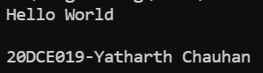

**OUTPUT-B:**

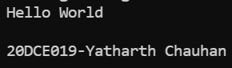

**CONCLUSION:** In this practical we learnt concept of multithreading in 2ways i.e. first by extending super class Thread and another by using Runnable Interface to get the threads run and we start the Thread by start() method which implicitly calls run() method.